**Demo: Creating Branch in GIT local Repository**

**Objective:** To create branch and merge a Git local repository for understanding the fundamentals of repository management and merge control using Git

**Tools required:** Git

**Prerequisites:** We need to have Git installed to proceed with this demo.

**Steps to be followed:**

1. Create a new Git, Branch and merge repository

**Step 1: Create a new Git, Branch and merge repository**

**1.1** Below command used to check current branch detail (git branch => *asterisks used to tell us current branch detail).

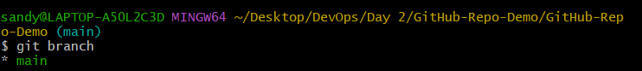

**1.2** Created an empty file using touch command in Git Local Repository (touch m1.txt => used to create empty file in our local Git repo)

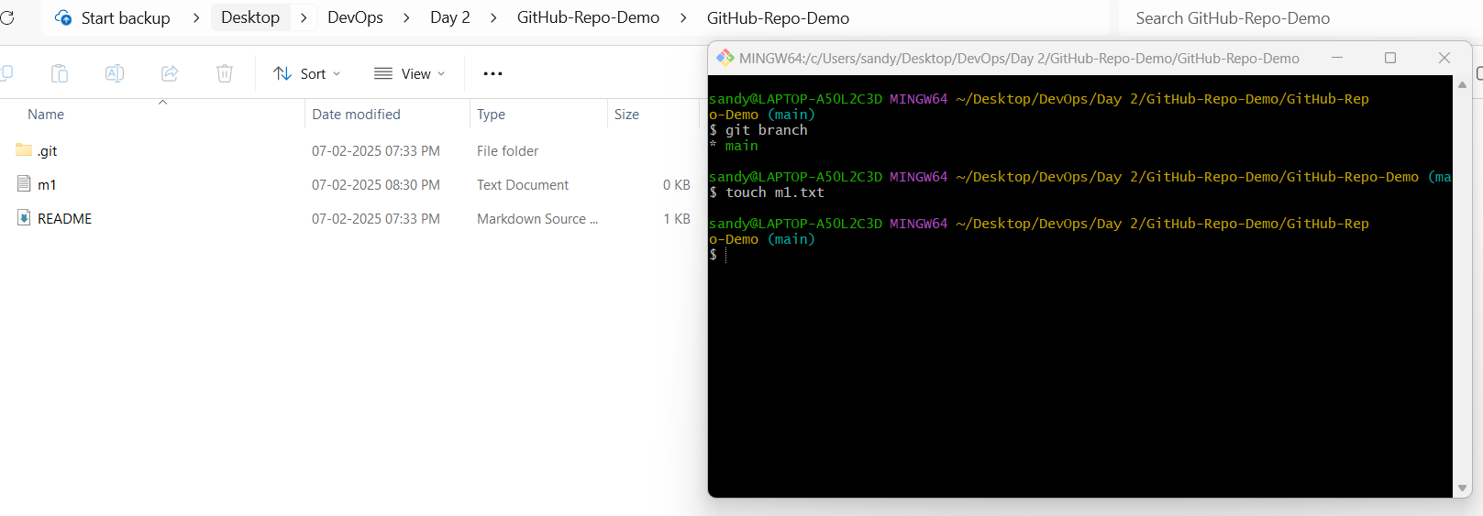

**1.3** Moving m1.txt file from working area to staging area and check status of file whether file is in staging area or not.

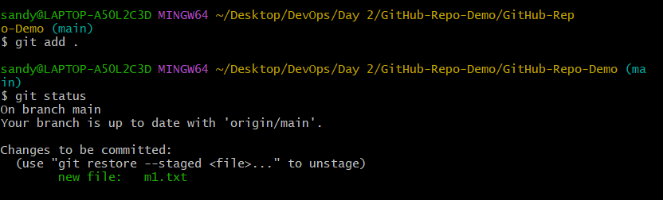

**1.4** Moving m1.txt file from staging area to commit area

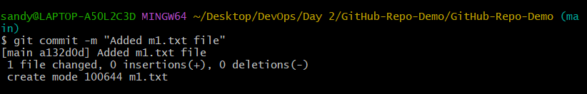  
**1.5** Check file whether pushed into branch or not

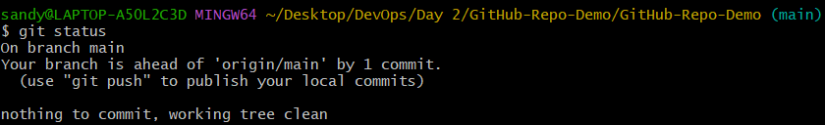

**1.6** Created an empty file using touch command in Git Local Repository (touch m2.txt => used to create empty file in our local Git repo)

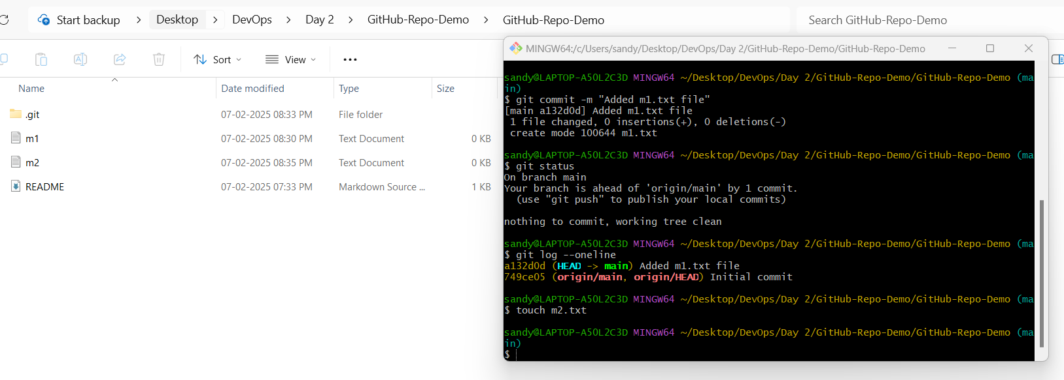

**1.7** Moving m2.txt file from working area to staging area and check status of file whether file is in staging area or not.

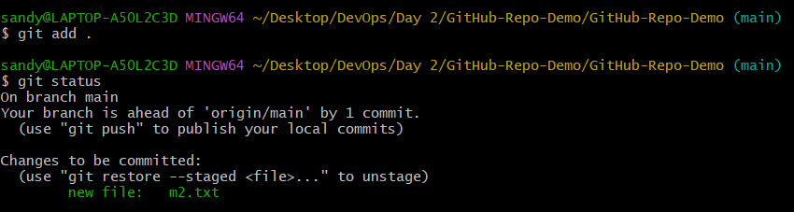

**1.8** Moving m1.txt file from staging area to commit area

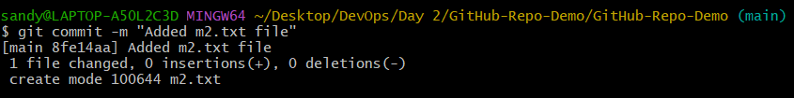

**1.9** Check commit detail of Main branch

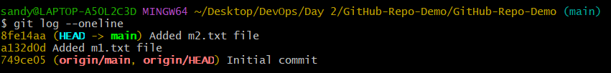

**1.10** m1.txt and m2.txt file generated in Git local repository

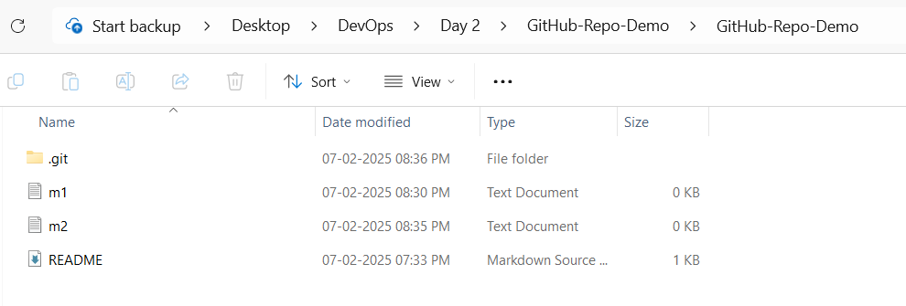

**1.11** Create new branch



**1.12** Swap from main branch to newly created (feature) branch



**1.13** Created an empty file using touch command in Git Local Repository (touch f1.txt => used to create empty file in our local Git repo)



**1.14** Below shows us f1.txt file created in local repo

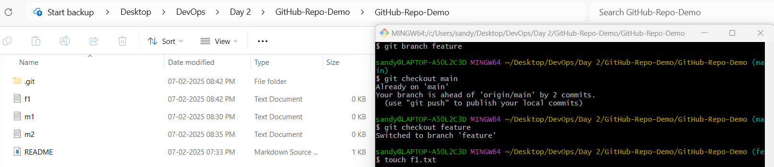

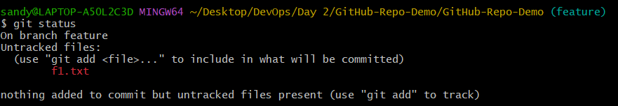

**1.15** Moving f1.txt file from working area to staging area.



**1.16** Moving f1.txt file from staging area to commit area.

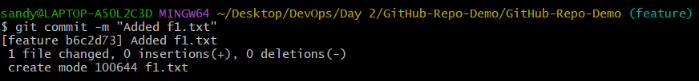

**1.17** Check commit detail of Feature branch (Below we could see m1 and m2 file in feature branch because branch has been created after m2.txt commit so in feature branch we could see total of three files)

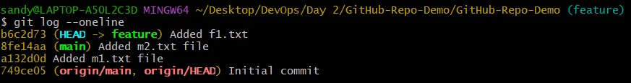

**1.18** Swap from feature branch to main branch

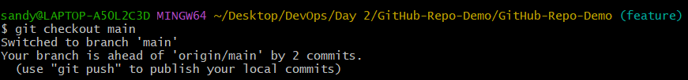

**1.19** m3.txt and m4.txt files are created in git repo local under main branch

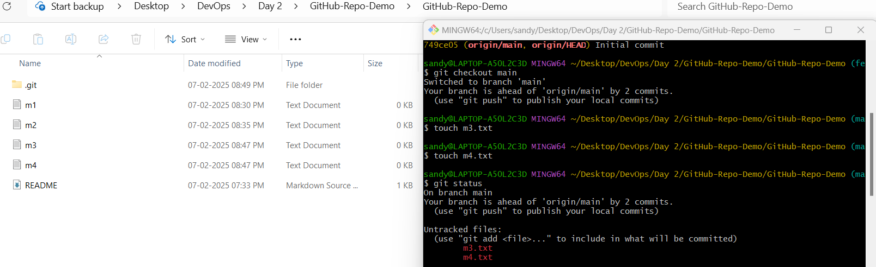

**1.20** Created two empty file using touch command in Git Local Repository and check files are in what area to proceed further (touch m3.txt and touch m4.txt => used to create empty file in our local Git repo)

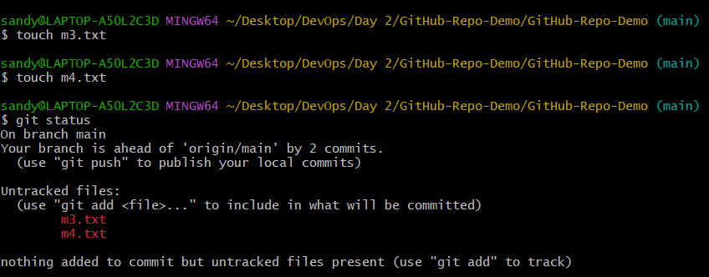

**1.21** Moving m3.txt and m4.txt files from working area to staging area.



**1.22** Moving m3.txt and m4.txt files from staging area to commit area.

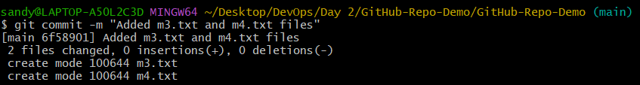

**1.23** Check commit detail of Main branch (Below we could see m1, m2, m3, m4 files in main branch because branch has been created after m2.txt commit so in feature branch we could see total of four files)

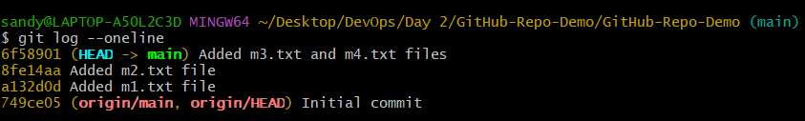

**1.24** Swap from main branch to feature branch



**1.25** Created an empty file using touch command in Git Local Repository (touch f2.txt => used to create empty file in our local Git repo)



**1.26** f2.txt file is created in git repo local under feature branch

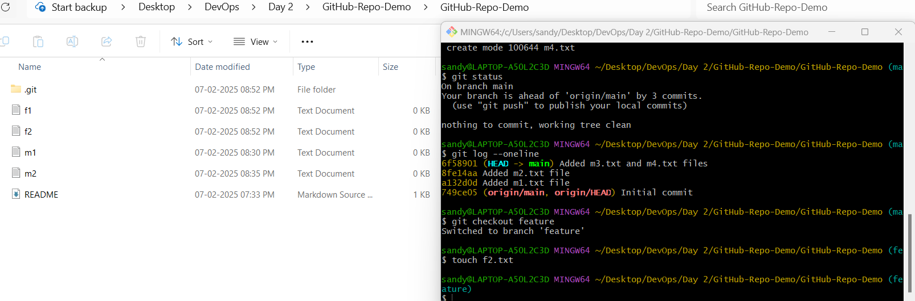

**1.27** Check files are in what area to proceed further.

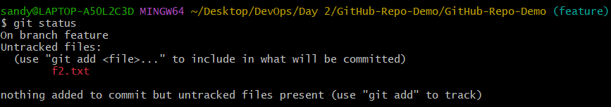

**1.28** Moving f2.txt files from working area to staging area.



**1.29** Moving f2.txt files from staging area to commit area.

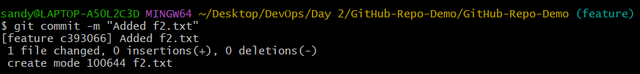

**1.30** Check commit detail of feature branch (Below we could see m1, m2, f1, f2 files in main branch because branch has been created after m2.txt commit so in feature branch we could see total of four files)

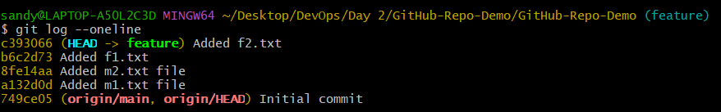

**1.31** Swap from feature branch to main branch.

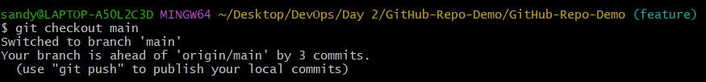

**1.32** Viewing files in local git repo and checkout from feature to main branch.

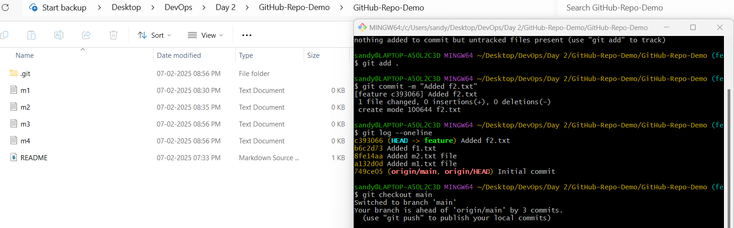

**1.33** Created an empty file using touch command in Git Local Repository (touch m5.txt => used to create empty file in our local Git repo)



**1.34** m5.txt file is created in git repo local under main branch

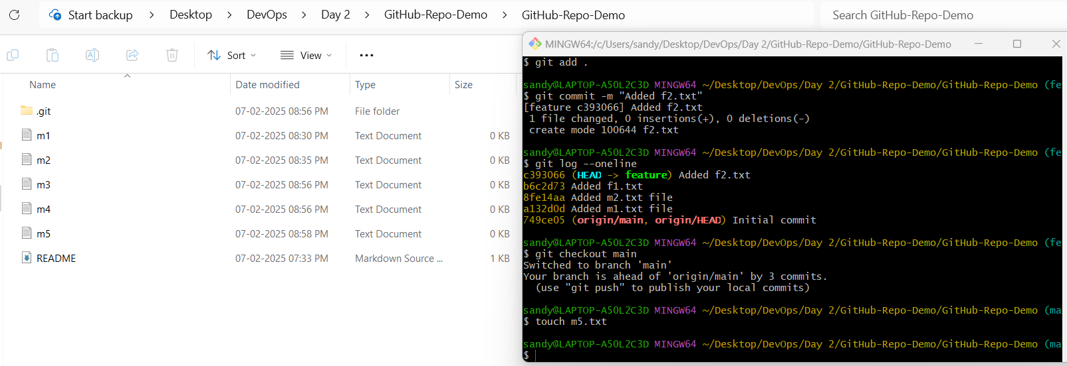

**1.35** Check files are in what area to proceed further.

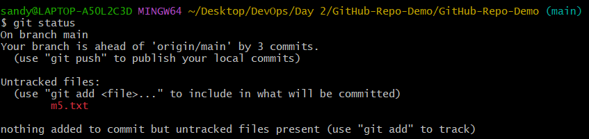

**1.36** Moving m5.txt file from working area to staging area. Moving m5.txt file from staging area to commit area.

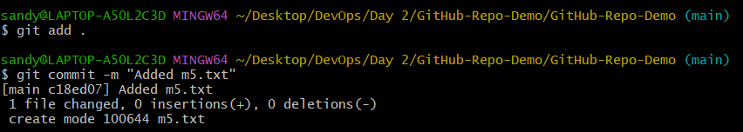

**1.37** Check commit detail of main branch (Below we could see m1, m2, m3, m4, m5 files in main branch because branch has been created after m2.txt commit so in main branch we could see total of five files)

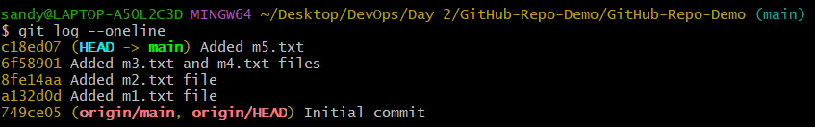

**1.38** By using **git merge branchname** command we can join from one branch to another branch.

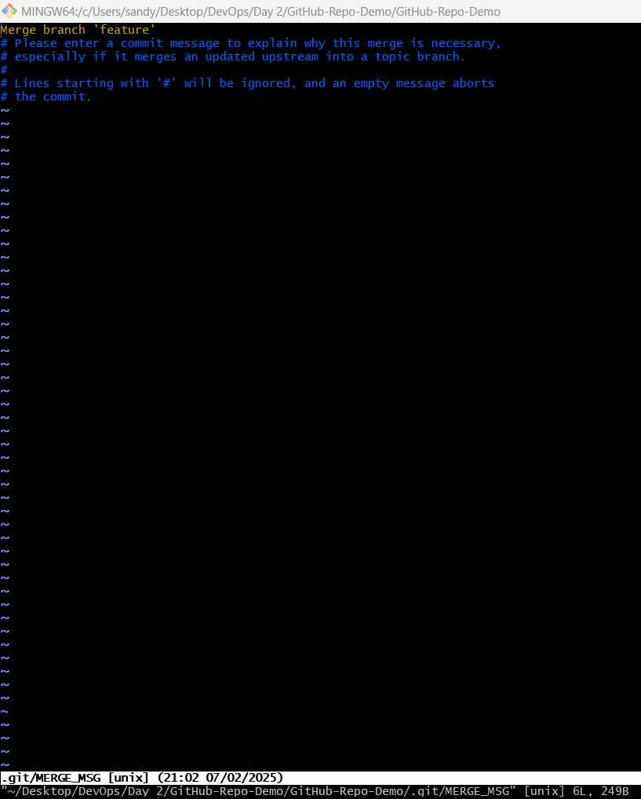

**1.39** Merge is getting existed by pressing **esc key** and enter **:wq** pressing **enter** will get confirmation for merge from one branch to another branch.

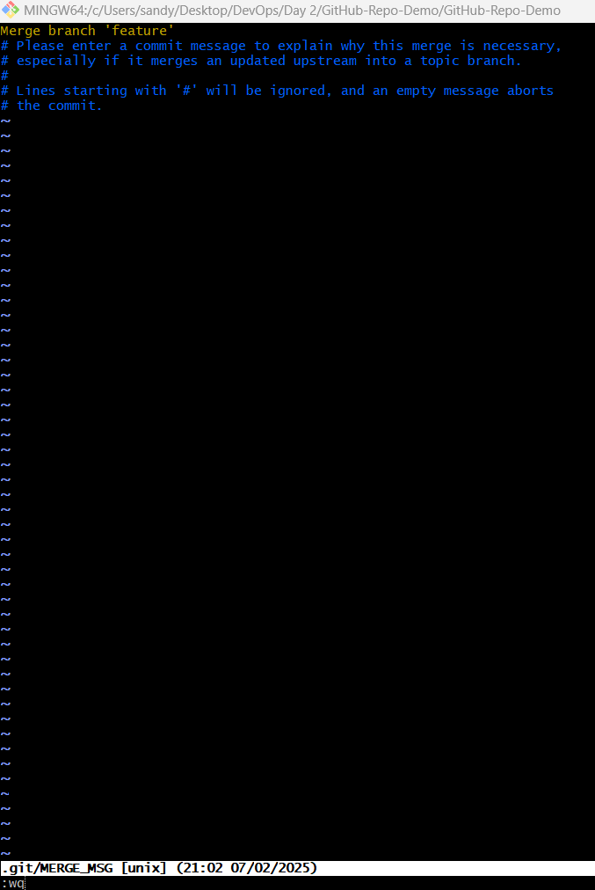

**1.40** Merge confirmation from one branch to another branch will take a copy of file from another branch.

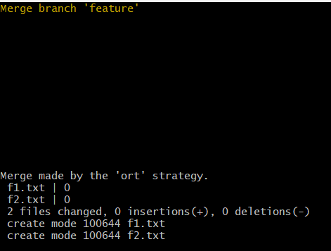

**1.41** Checking local git repo of feature branch (total file of four files are presented in feature branch) and checking out fromfeature branch.

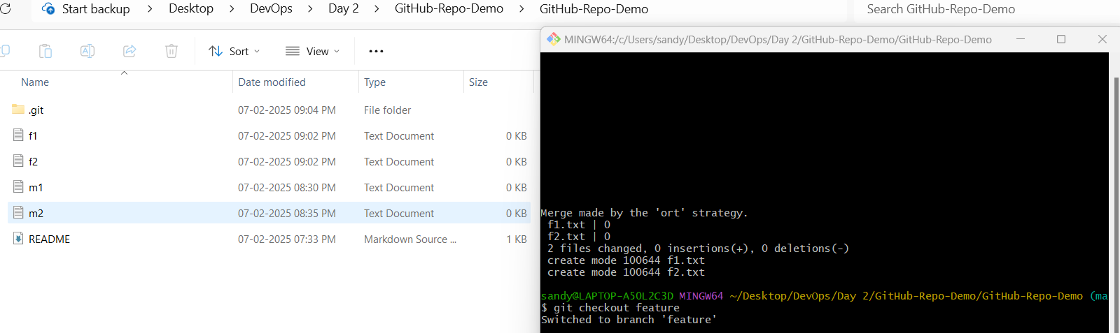

**1.42** Checking local git repo of main branch (total file of seven files are presented in main branch)

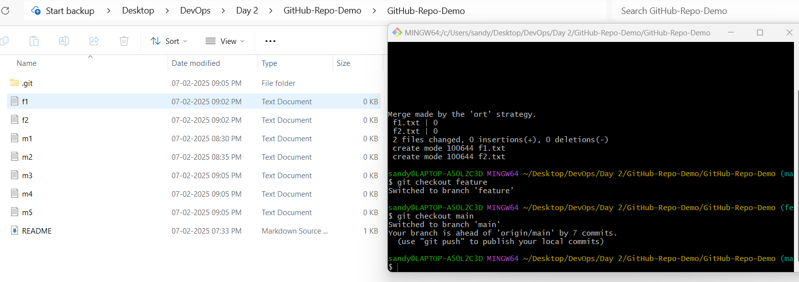

**1.43** Below command is used to delete branch but here we are getting error because of currently git local repo is pointed to branch we are trying to delete.

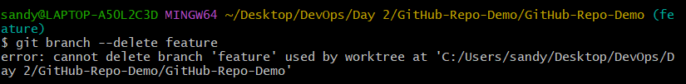

**1.44** Checking out from feature to main to delete feature branch.

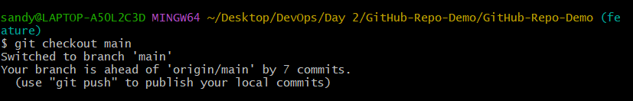

**1.45** Successfully deleting our feature branch.



**1.46** Trying to switching from main to feature branch but we are getting error since that branch has been removed from local git repo.

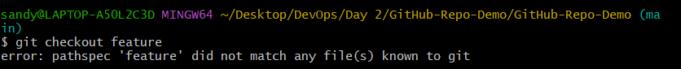

**1.47** Check commit detail of main branch (Below now we could see m1, m2, m3, m4, m5, f1 and f2 files in main branch because from feature branch we moved f1 and f2 files into main branch)

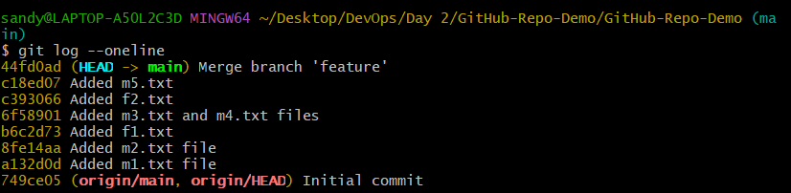

**1.48** Check main branch status whether we have up to date or not.

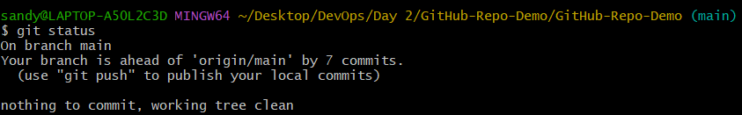

**1.49** Full detail of commit, author and datetime will be published.

